Chapter 15, Problem 48.

Find f(t) using convolution given that:

(a) 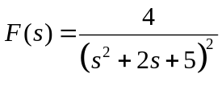
(b) 